My Links
Administration Section
As an Administrator for your company; you have the ability to add and edit links that will appear as icons on your company Dashboard.
To add or edit icons under My Links, we start off with accessing the Admin section via the Admin button at the top right side of your website. If you do not see this button, you may not have the proper administration privileges in the system.

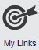
Once you are in the Administration section, click on My Links. Once you are under this menu, click on Manage My Links to add or edit My Links icons.

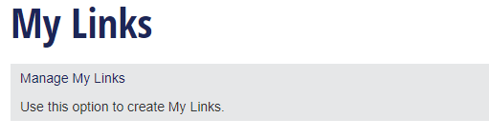
Once you are on the Manage My Links page, start by selecting the My Links feature.
Once you have selected the feature, the page will list existing My Links icons.
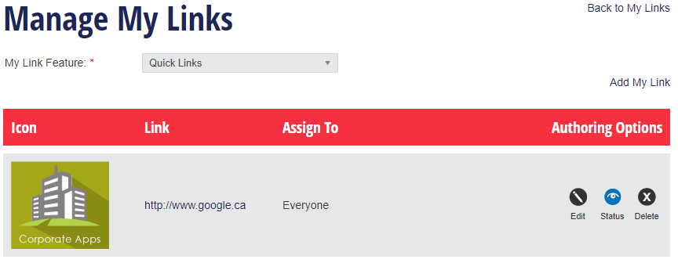

Add My Links
To add a new link icon, click the Add My Link button in the top right.
On the Add My Link page, by default the system will select the same My Links feature that you had selected on the Manage My Links page, but you can change this here if needed.
In the icon field, click the Browse button to attach an image from your computer. If you have multiple languages, you will need to attach this image separately for each language.
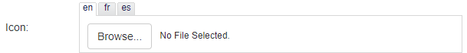
The system will resize the image you upload to fit into a square field approximately 125 by 125 pixels. It is recommended that you use square images, where the length is equal to the width of the image. Recommended image size is 125 by 125 pixels.
Once you have chosen an image, enter the website hyperlink in the Link field. For an external web address, ensure to include the prefix http:// or https:// at the front of the link.
The Open in New Tab option allows you to choose whether you want the link to open in a new tab in your browser, or in the same tab.
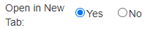
The Status field determines whether a link will be visible or not on the dashboard. If status is set to Active, the link will appear in the My Links dashboard widget for any assigned users. If status is set to Inactive, the link will not be visible to users in the My Links Dashboard widget until it is changed to active.
The Assign To field allows you to decide which users are able to see the link in their dashboard widget.
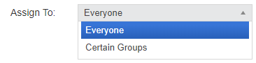
There are five ways to assign a link:
- Everyone in the company
- Everyone within a specific level of the Company
- Users who have a specific Category assigned to them
- Users with a specific Admin level
- Specific users
You can assign this link to more than one Certain Group, just click Add Another Assignment and select the organizational level or user from the drop-down menus.
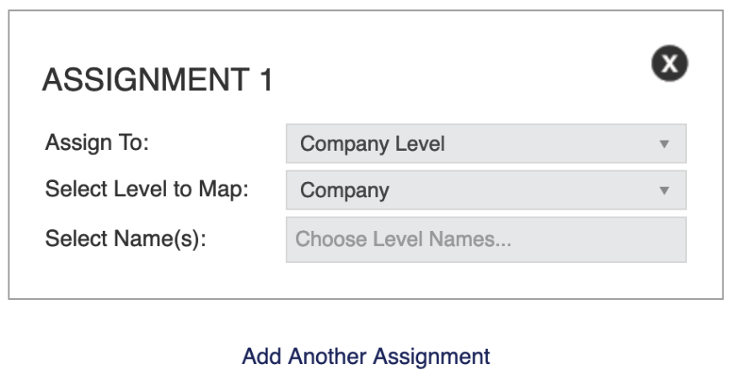
When you are finished, click Save. You can click Cancel at any time to return to the Manage My Links page, but your work will not be saved.

Edit My Links
If you need to make any edits to existing links, you can do this through the Manage My Links page. For each link, the table displays the image used for the icon, the address of the link, and who the link is assigned to.
By default, the links on this page are ordered by the date that they are added, but you can order the links by clicking and dragging any of the entries in the table.
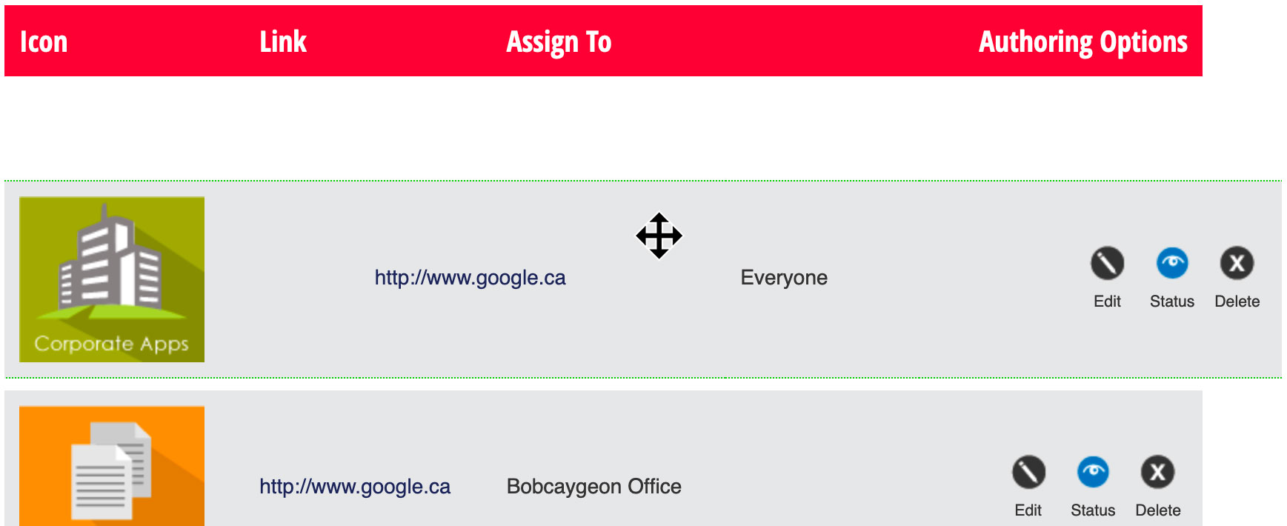
After you have finished sorting your entries, click the Save Sorting button located above the table header on the left-hand side. Click Cancel to abort the changes.

You have several options in the Authoring Options column for managing my links.
To edit a link, select the pencil icon. Make any necessary changes and click Update to save the updated link.
If you need to inactivate (hide) a link, simply select the blue open eye icon. This will change the status to inactive and the icon will now be a grey closed eye.
If you need to activate a link, simply select the grey closed eye icon. This will change the status to active and the icon will now be a blue open eye.
If you need to delete a link, simply select the X icon next to the link you wish to remove. This will remove the link permanently.

