Employee Settings -
Import Functionality
Administration User Guide

Table of Contents
Employee Settings Import Functionality 3
Import Course Scores 2
Import Library File View/Sign-Off 4
Import Monthly Talk Completion 6
Import Survey Completion 7

Employee Settings Import Functionality
Do you complete classroom-based training for items housed on Systems 24-7, such as training, monthly talks, surveys, or library sign-offs? As an administrator, you can easily import these items into Systems 24-7.

Import Course Scores
The import course scores function can be used to import scores/records into Systems 24-7 for courses completed offline. There must be a course on Systems 24-7 in order to upload the record. An import is a quicker solution when more than 10 employees need to have scores added. To import scores, follow these steps.
Step 1: From the admin menu, select Employee Settings. If you do not have access to the administration section or are missing this setting, you do not have permission. Speak to your company or Systems 24-7 administrator.
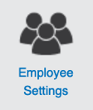
Step 2: Select Import Course Scores from the list of employee settings.
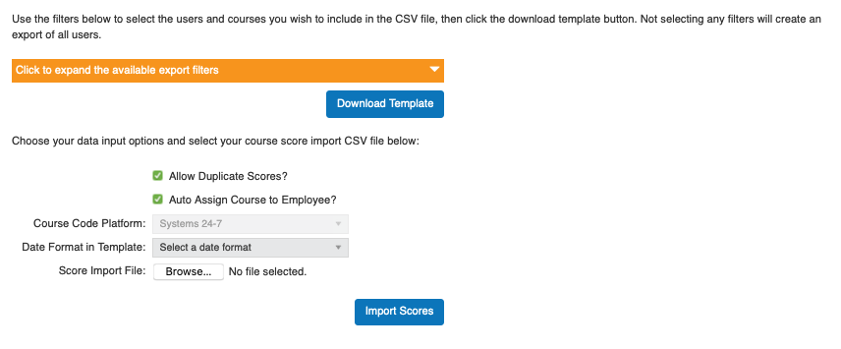
Step 3: The tool has the ability to create a customized template making your imports easier. Depending on your permissions as an administrator, you can create an import sheet. Click the available export filters to expand your template options.
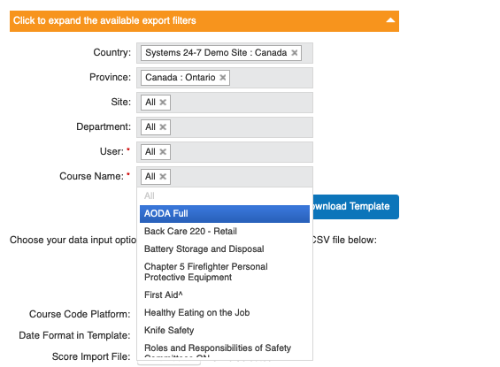
Select how you would like to set-up your import template. Here are some examples to get you started:
- You may want to create a template of all users within a specific department. To do this, select the department and select download template.
- You may want to create a template of all users within the company who attended onsite training equivalent to a specific online course (or placeholder). To do this, select the course name from the dropdown and select download template.
Step 4: A .csv file will download to your computer. Open the .csv file and complete the import sheet for the data you need to import. In order for the scores to successfully import, all information in the file needs to be accurate (and consistent with the data in Systems 24-7).
For each employee that requires a score, enter in the date completed and percentage score for each course.
In the date complete column, enter in the date format in one of the following formats:
- MM/DD/YYYY
- YYYY/MM/DD
- YYYY/DD/MM
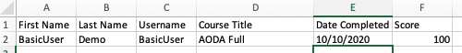
Step 5: Save your .csv file.
Step 6: On Systems 24-7, select whether you want to allow duplicate scores. This means that if the user already has a record in the system, you will allow another record to replace it. Also check off whether you want to auto assign the course to the employee. This means that if the employee has not been assigned this course, by importing the score, you will assign it to their list of training.
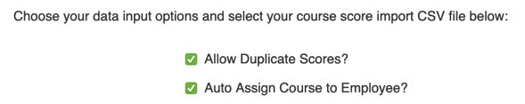
Step 7: Select the date format you selected to use in your import sheet.
Step 8: Select the browse button and attach your .csv import sheet. When finished, select the import button in the lower right-hand corner.
Allow the import to run. If you have an email associated with your account, you will be emailed a copy of the report, along with any errors in being able to import the score.
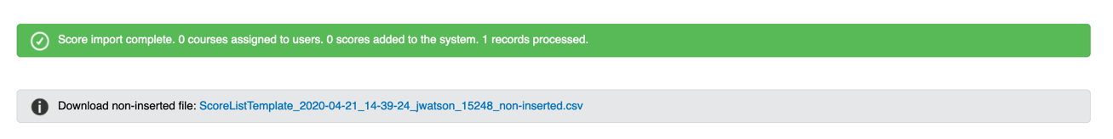
Step 9: If there were issues with the import sheet, below the confirmation prompt of the import will be an alert with a .csv file of any scores that were not imported. This could be due to a typo in the first name, last name, username (or employee number), course name, etc. We recommend using the Add course scores tool to manually add scores you were unable to import.

Import Library File View/Sign-Off
The import library file view/sign-off function can be used to import views/sign-offs into Systems 24-7 for library documents loaded online. There must be a library resource on Systems 24-7 in order to upload the view/sign-off. An import is a quicker solution when more than 10 employees need to have records added. Why would you need this? Perhaps you reviewed a policy with a group of employees or maybe you posted a document on a staff board and had employees sign it after they read it. Whatever the reason, to import views/sign-offs to library resources follow these steps.
When you import a view to a library item, if there is a sign-off requirement turned on for that item, the sign-off will also be uploaded.
Step 1: From the admin menu, select Employee Settings. If you do not have access to the administration section or are missing this setting, you do not have permission. Speak to your company or Systems 24-7 administrator.
Step 2: Select Import Library File View/Signoff from the list of employee settings.
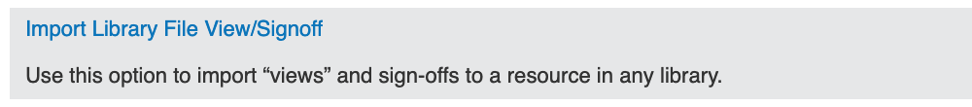
Step 3: Select the option to download a sample score import and select okay. This will download a .csv file to your computer.
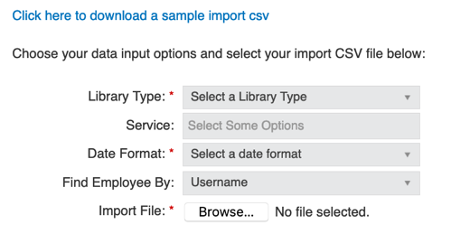
Step 4: Open the .csv file and complete the import sheet for the data you need to import. In order for the views/sign-offs to successfully import, all information in the .csv file needs to be accurate (and consistent with the data in Systems 24-7).
Enter in the employee’s first name, last name, username (if unknown you can place the employee numbers in this field), library header (must match the header online), resource name, and date completed. If you make errors in any of the fields, there will be issues with being able to match records to employees.
In the date complete column, enter in the date format in one of the following formats:
- MM/DD/YYYY
- YYYY/MM/DD
- YYYY/DD/MM
Step 5: Save your .csv file.
Step 6: Select the library type and service to upload the view/sign-off to.
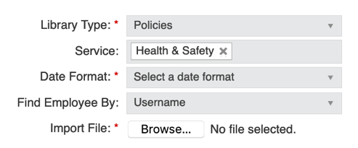
Step 7: Select the date format you selected to use in your import sheet.
Step 8: Select how you wish to find the employee. If you used usernames in the spreadsheet, then select username. If you chose to use employee numbers instead, then select employee number.
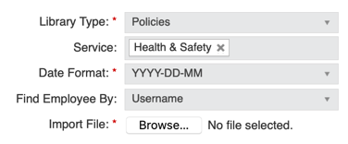
Step 9: Select the browse button and attach your .csv import sheet. When finished, select the import button in the lower right-hand corner.
Allow the import to run. If you have an email associated with your account, you will be emailed a copy of the report, along with any errors in being able to import the score.
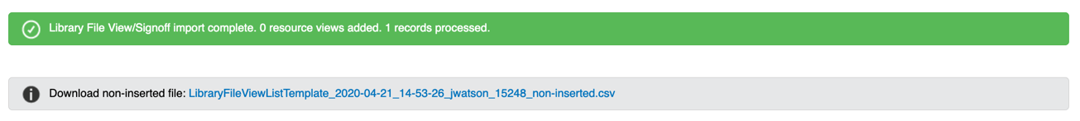
Step 10: If there were issues with the import sheet, below the confirmation prompt of the import will be an alert with a .csv file of any views/sign-offs that were not imported. This could be due to a typo in the first name, last name, etc. We recommend using the Add Resource View tool to manually add views you were unable to import.

Import Monthly Talk Completion
The import monthly talk completion function can be used to import the record of completion of monthly talks into Systems 24-7. There must be a monthly talk online on Systems 24-7 in order to upload the review. An import is a quicker solution when more than 10 employees need to have records added. Why would you need this? Perhaps you reviewed a monthly talk in person with a group of employees? Whatever the reason, to import a completion of a monthly talk, follow these steps.
When you import a completion, you are adding a record of the employee viewing the monthly talk, answering any related quiz questions, and completing their sign-off, if one was enabled.
Step 1: From the admin menu, select Employee Settings. If you do not have access to the administration section or are missing this setting, you do not have permission. Speak to your company or Systems 24-7 administrator.
Step 2: Select Import Monthly Talk Completion from the list of employee settings.
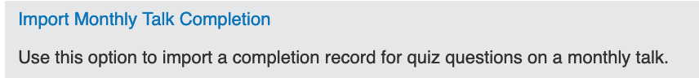
Step 3: Select the option to download a sample score import and select okay. This will download a .csv file to your computer.
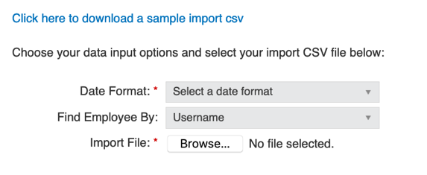
Step 4: Open the .csv file and complete the import sheet for the data you need to import. In order for the completion to successfully import, all information in the .csv file needs to be accurate (and consistent with the data in Systems 24-7).
Enter in the employee’s first name, last name, username (if unknown you can place the employee numbers in this field), monthly talk name (must match the monthly talk online), and date completed. If you make errors in any of the fields, there will be issues with being able to match completion records to employees.
In the date complete column, enter in the date format in one of the following formats:
- MM/DD/YYYY
- YYYY/MM/DD
- YYYY/DD/MM
Step 5: Save your .csv file.
Step 6: Select the date format you selected to use in your import sheet.
Step 7: Select how you wish to find the employee. If you used usernames in the spreadsheet, then select username. If you chose to use employee numbers instead, then select employee number.
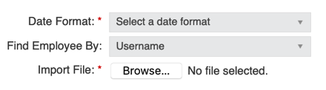
Step 8: Select the browse button and attach your .csv import sheet. When finished, select the import button in the lower right-hand corner.
Allow the import to run. If you have an email associated with your account, you will be emailed a copy of the report, along with any errors in being able to import the completion record.
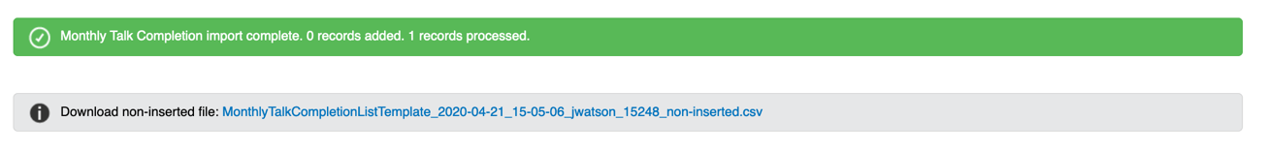
Step 10: If there were issues with the import sheet, below the confirmation prompt of the import will be an alert with a .csv file of any views/sign-offs that were not imported. This could be due to a typo in the first name, last name, etc. Make any changes and re-import or use the Add Monthly Talk View/Sign-Off tool to manually add completion records you were unable to import.

Import Survey Completion
The import survey completion function can be used to import the completion of surveys into Systems 24-7. There must be a survey online on Systems 24-7 in order to upload the completion. To import the survey completion, follow these steps.
When you import a completion, you are adding a record of the employee completing the survey, not a record of their survey responses.
Step 1: From the admin menu, select Employee Settings. If you do not have access to the administration section or are missing this setting, you do not have permission. Speak to your company or Systems 24-7 administrator.
Step 2: Select Import Survey Completion from the list of employee settings.
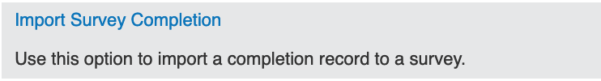
Step 3: Select the option to download a sample score import and select okay. This will download a .csv file to your computer.
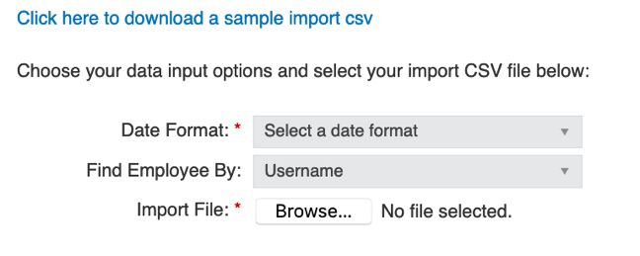
Step 4: Open the .csv file and complete the import sheet for the data you need to import. In order for the completion to successfully import, all information in the .csv file needs to be accurate (and consistent with the data in Systems 24-7).
Enter in the employee’s first name, last name, username (if unknown you can place the employee numbers in this field), survey name (must match the survey name online), and date completed. If applicable, you can also enter in company level and company entity name (ie. department and department name). If you make errors in any of the required fields, there will be issues with being able to match completion records to employees.
In the date complete column, enter in the date format in one of the following formats:
- MM/DD/YYYY
- YYYY/MM/DD
- YYYY/DD/MM
Step 5: Save your .csv file.
Step 6: On Systems 24-7 Select the date format you selected to use in your import sheet.
Step 7: Select how you wish to find the employee. If you used usernames in the spreadsheet, then select username. If you chose to use employee numbers instead, then select employee number.
Step 8: Select the browse button and attach your .csv import sheet. When finished, select the import button in the lower right-hand corner.
Allow the import to run. If you have an email associated with your account, you will be emailed a copy of the report, along with any errors in being able to import the completion record.
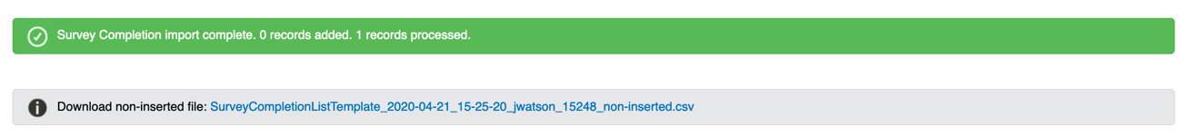
Step 9: If there were issues with the import sheet, below the confirmation prompt of the import will be an alert with a .csv file of any records that were not imported. This could be due to a typo in the first name, last name, etc. Make the corrections and re-import.

